**ps command:**

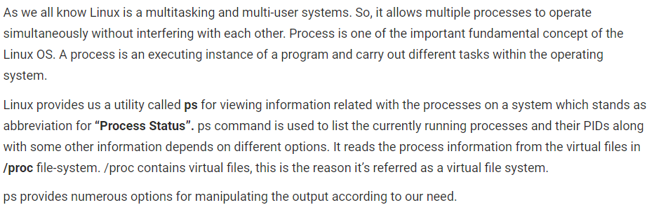

**Simple process selection:**

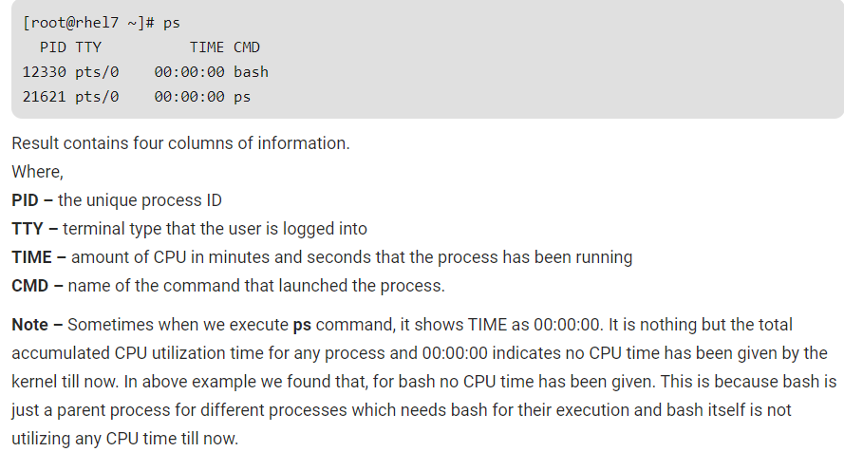

**View Processes:**

View all the running processes use either of the following option with ps –

* **ps -A**
* **ps -e**

View Processes not associated with a terminal:

View all processes except both session leaders and processes not associated with a terminal.

* **ps -a**

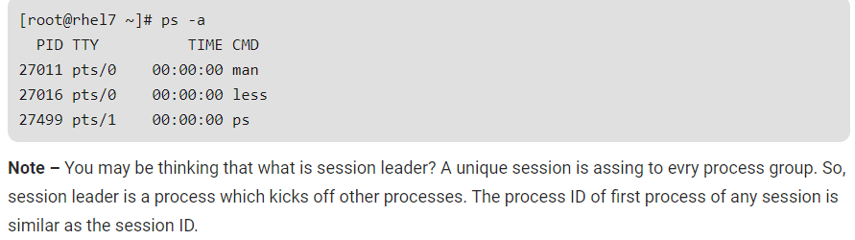

View all the processes except session leaders:

* **ps -d**

View all processes except those that fulfill the specified conditions (negates the selection):

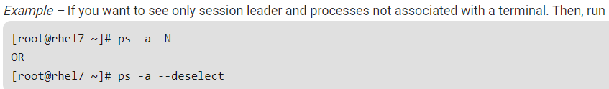

View all processes associated with this terminal:

* **ps -T**

View all the running processes:

* **ps -r**

View all processes owned by you:

* **ps -x**

**process selection by list:**



Select the process by the command name. This selects the processes whose executable name is given in cmdlist. There may be a chance you won’t know the process ID and with this command it is easier to search.

* **ps -C command_name**

Select by group ID or name. The group ID identifies the group of the user who created the process.

* **ps -G group_name**
* **ps --Group group_name**

View by group id

* **ps -g group_id**
* **ps -group group_id**

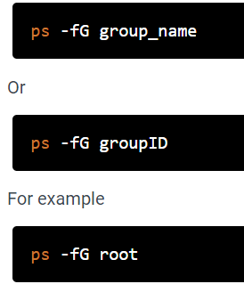

View process by process ID

* **ps p process_id**
* **ps -p process_id**
* **ps --pid process_id**

You can view multiple processes by specifying multiple process IDs separated by blank or comma –

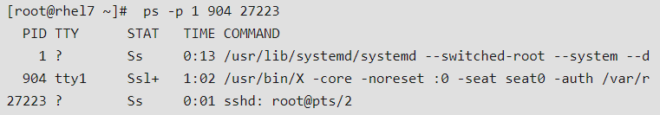

Select by parent process ID. By using this command, we can view all the processes owned by parent process except the parent process.

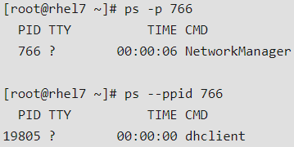

View all the processes belongs to any session ID

* **ps -s session_id**
* **ps --sid session_id**

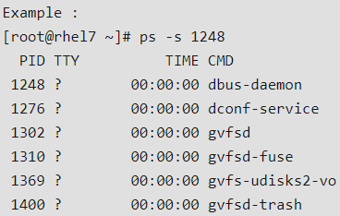

Select by effective user ID or name.

* **ps U user_name/ID**
* **ps -U user_name/ID**
* **ps -u user_name/ID**
* **ps –User user_name/ID**
* **ps –user user_name/ID**

**output format control:**

These options are used to choose the information displayed by ps. There are multiple options to control output format. These options can be combined with any other options like e, u, p, G, g etc, depends on our need.

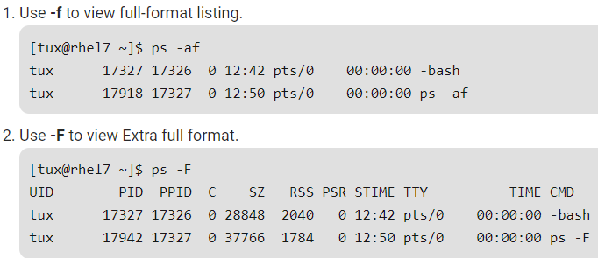

To view a full format listing run

